**Project Design Phase-II**

**Technology Stack (Architecture & Stack)**

|  |  |
| --- | --- |
| Date | 03 November 2022 |
| Team ID | PNT2022TMID5315 |
| Project Name | Project - Signs with Smart Connectivity for Better Road Safety |
| Maximum Marks | 4 Marks |

**Technical Architecture:**

The Deliverable shall include the architectural diagram as below and the information as per the table1 & table 2

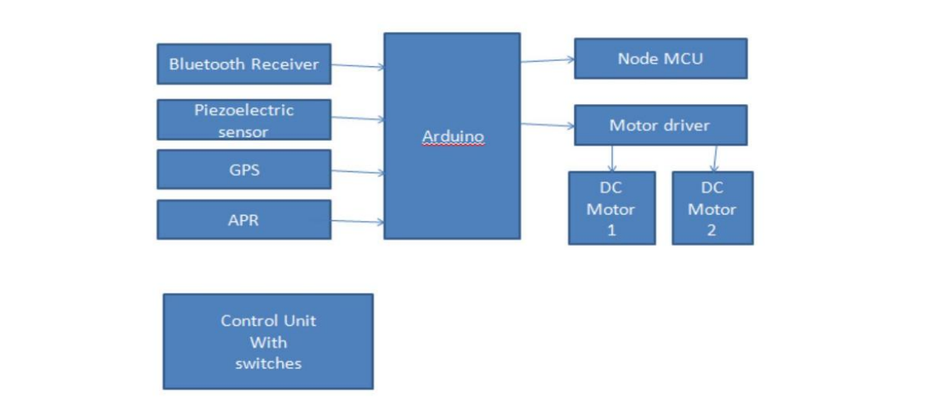

**Table-1 : Components & Technologies:**

|  |  |  |  |
| --- | --- | --- | --- |
| **S.NO** | **COMPONENTS** | **DESCRIPTION** | **TECHNOLOGIES** |
| **1.** | **User Interface** | **How user interacts with**  **application e.g. Web UI, Mobile**  **App, Chatbot etc.** | **HTML, CSS, JavaScript / Angular JS / React JS etc.** |
| **2.** | **Application logic-2** | **Logic for a process in the**  **application** | **IBM Watson STT service** |
| **3.** | **Application logic-3** | **Logic for a process in the application** | **IBM Watson Assistant** |
| **4.** | **Cloud Database** | **Database Service on Cloud** | **IBM DB2, IBM Cloudant etc.** |
| **5.** | **External API - 1** | **Purpose of External API used in the application I** | **IBM Weather API etc.** |

**Table-2: Application Characteristics:**

|  |  |  |  |
| --- | --- | --- | --- |
| **S.NO** | **CHARACTERISTICS** | **DESCRIPTION** | **TECHNOLOGIES** |
| **1.** | **Security Implementations** | **Strong security measures prevent hackers and users without login credentials from accessing the network.** | **Firewall, Firebase, cyber resiliency strategy** |
| **2.** | **Scalable Architecture** | **By expanding the network's bandwidth, the operating range can be upgraded.** | **IoT, internet.** |
| **3.** | **Availability** | **Available at all times and locations 24/7 so long as the user is logged into the network.** | **IBM Cloud** |
| **4.** | **Performance** | **Allows a lot of people to use the**  **technology at the same time.** | **IBM Cloud** |